Lab1: Inspecting Table Size

Lab2: The Impact of a New Index
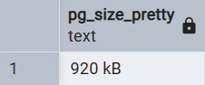
Before CREATE INDEX:

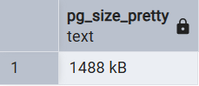
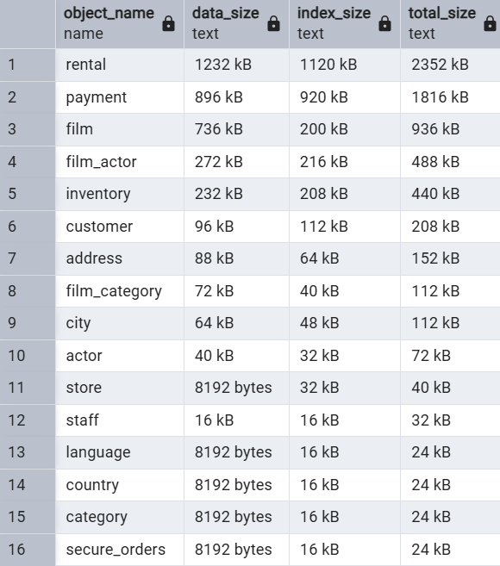
After CREATE INDEX:

The new index consumes $\frac{1488-920}{8}= 71 pages$

Lab3: Partial Index Practice
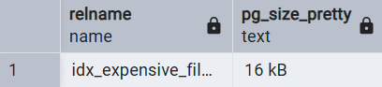
Partial index on replacement_cost

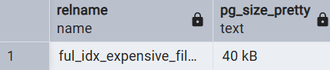
Full index on replacement_cost

